**Lab 5** 10/10/2018

**Active Filter Design Using Webench™**

**Objective**

To design an active band pass filter using as assigned frequency which is (Tone F – 1396.91Hz)

**Equipment/Tools Used**

Webench TI platform

Op-Amp lm348

Resistors

Capacitors

**Procedure**

* Register and Login to your account in TI Webench
* Start designing the design in the Webench, enter the frequency assigned, gain, and bandwidth for the particular design
* As asked that the amplifier should be in two stages the bandwidth value should be low
* Select the type of the filter necessary for our design from Bessel, Butterworth or Chebyshev depending on the characteristics of each filters.
* Turn the tolerance as 1% for the better output.

**Observation**

* Now at this stage we will be getting the circuit diagram and the output waveform for the selected center frequency(1396.9Hz)
* And as we have selected the Butterworth filter we can see this particular output.
* On comparing the same frequency with different filter type outputs, we get a exact output while using the Butterworth filter
* We can also observe that the area under the filter of Butterworth is more so it will be helpful for us for the further processing

**Discussion**

* Just I made a comparison from all the graphs and I came up with a conclusion that

Butterworth will be more efficient

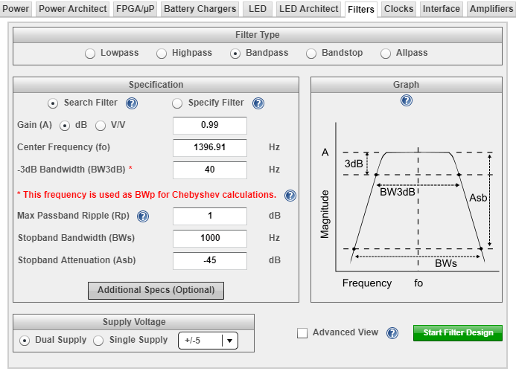

Fig: 5.1 Step 1 the place where the parameters are given

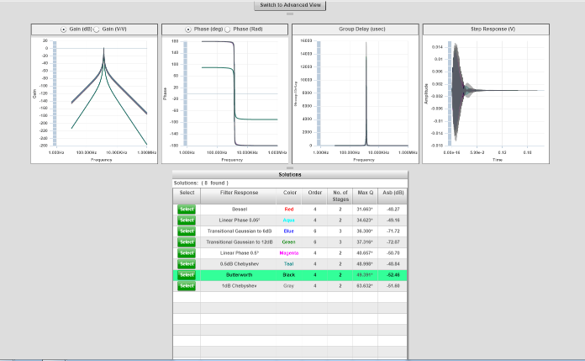

Fig: 5.2 this is the place where the type of the filter is selected

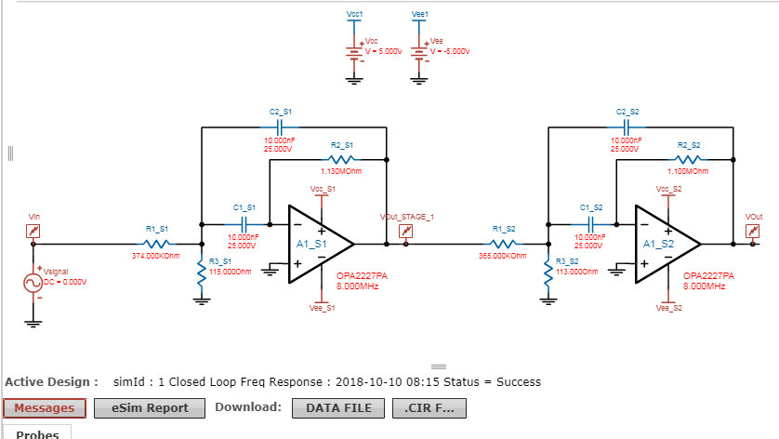

Fig: 5.3 Circuit Diagram for Butterworth Filter

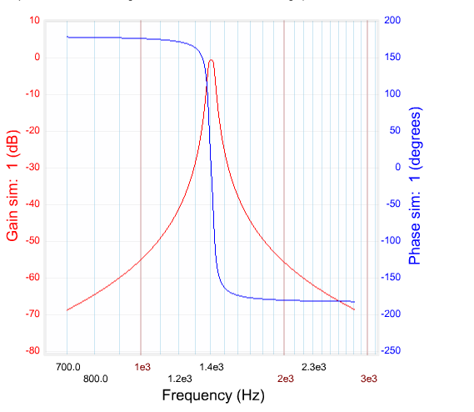

Fig: 5.4 Output Waveform of Butterworth Filter-Closed loop frequency

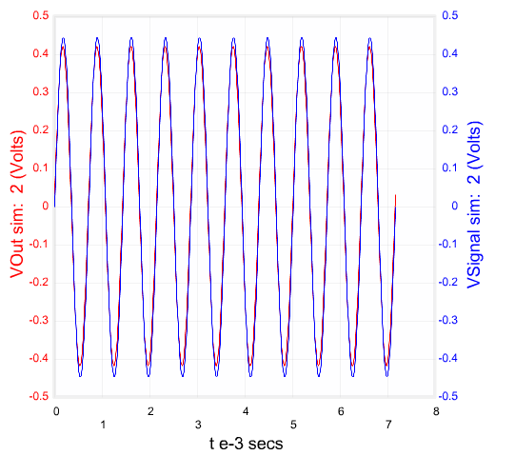

Fig: 5.5 Output Waveform of Butterworth Filter-Sine Wave

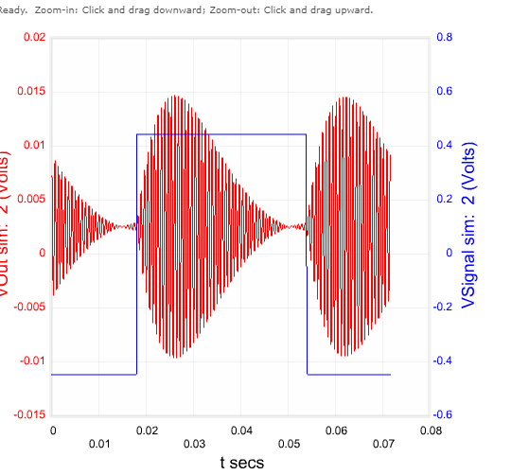

Fig: 5.6 Output Waveform of Butterworth Filter – Step wave

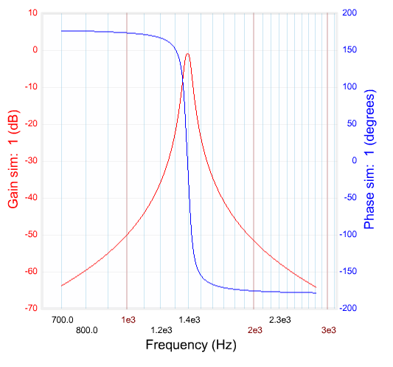

Fig: 5.7 Output Waveform of Bessel Filter - Closed loop Frequency

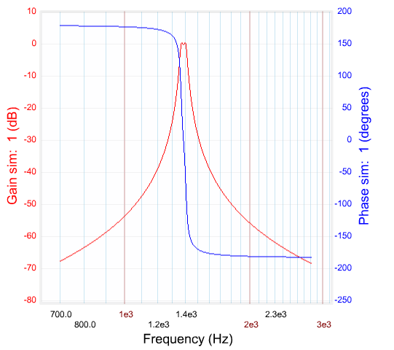

Fig: 5.8 Output Waveform of Chebyshev Filter - Closed loop Frequency

**Discussion**

* In my circuit I have used the gain as 1db, Bandwidth 40Hz, Centre Frequency as 1396.91Hz and the tolerance should be 1% for all the cases.
* In figure 5.5 for the sin wave input we can find that the output mostly coincides with the input and that is what the reason I have chosen this particular filter where in rest this is not the case.
* It shows the components used in the circuit values as follows R 2.2M, 750K, 58Ohm and Capacitance 10nF

**Conclusion**

Thus, an active band pass filter is simulated graphically with an assigned frequency and it was compared with all the other filter types and got the responses of the same.